[ ] Indicates material parenthetical to the worship planners, to be deleted from the worship folder
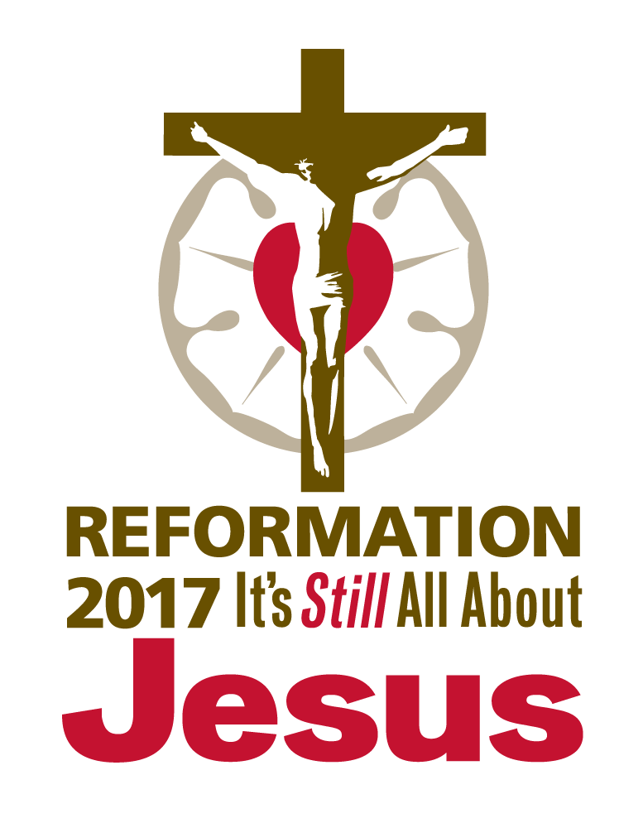
( ) Indicates instructions to the congregation, to appear in the worship folder

COMMEMORATION OF MARTIN LUTHER—BIRTH

November 10, 2016
Observed: November 13, 2016

AS WE GATHER

The writer of the Letter to the Hebrews encourages God’s people to remember those who have been faithful leaders: “Remember your leaders, those who spoke to you the word of God. Consider the outcome of their way of life, and imitate their faith” (Hebrews 13:7). Although Martin Luther was a humble man and always kept full focus on Jesus Christ, his contributions to the rediscovery of the Gospel and the reformation of the Christian Church are worthy of remembrance and thanksgiving. For a fuller understanding of the man, his work, and his era, we look to the beginning of his earthly story—the time of his birth at Eisleben, Germany, in 1483. The life of Martin Luther is an example of how God works in amazing ways through seemingly unlikely people—people like us—to accomplish His good and gracious will.

CONFESSION AND ABSOLUTION

HYMN OF INVOCATION “Come, Holy Ghost, God and Lord” [LSB 497; LW 154; TLH 224]

INVOCATION

The sign of the cross may be made by all in remembrance of their Baptism.

Pastor: In the name of the Father and of the Son and of the Holy Spirit.
People: Amen.

CONFESSION AND ABSOLUTION

Pastor: If we say we have no sin, we deceive ourselves, and the truth is not in us.
People: But if we confess our sins, God, who is faithful and just, will forgive our sins and cleanse us from all unrighteousness.

Silence for reflection on God’s Word and for self-examination.

Pastor: Let us then confess our sins to God our Father.
People: Most merciful God, we confess that we are by nature sinful and unclean. We have sinned against You in thought, word, and deed, by what we have done and by what we have left undone. We have not loved You with our whole heart; we have not loved our neighbors as ourselves. We justly deserve Your present and eternal punishment. For the sake of Your Son, Jesus Christ, have mercy on us. Forgive us, renew us, and lead us, so that we may delight in Your will and walk in Your ways to the glory of Your holy name. Amen.

Pastor: Almighty God in His mercy has given His Son to die for you and for His sake forgives you all your sins. As a called and ordained servant of Christ, and by His authority, I therefore forgive you all your sins in the name of the Father and of the Son and of the Holy Spirit.
People: Amen.

[OR]

Pastor: Let us now confess our sins to God our Father.
People: Lord, to You we make confession. We are by nature sinful and unclean, and we deserve Your wrath and eternal punishment. We have sinned in our thoughts, through our words, and by our deeds. We have not loved You with our whole heart and have not attended to the needs of our neighbors as is our duty. With contrite spirits, we come to You for forgiveness. Your Son, Jesus Christ, has suffered and died for us and has given Himself to rescue us and to reconcile us to You. For His sake, forgive and restore us. Renew us by Your Holy Spirit that we may amend our sinful lives and live to Your glory as Your beloved children.

Pastor: The eternal and gracious God has promised forgiveness of sins to those who repent and turn to Him. As a called and ordained servant of Christ and at His bidding, I forgive you all your sins in the name of the Father and of the Son and of the Holy Spirit.
People: Amen.

Pastor: Now may the God of peace Himself sanctify you completely, and may your whole spirit and soul and body be kept blameless at the coming of our Lord Jesus Christ. He who calls you is faithful; He will surely do it. Be at peace. (1 Thessalonians 5:23–24)
People: Amen.

SERVICE OF THE WORD

INTROIT Psalm 78:4–7; antiphon: Psalm 111:2

Great are the works | of the Lord,*
studied by all who de- | light in them.

We will not hide them from their children,
but tell to the coming generation
the glorious deeds of the Lord, | and His might,*
and the wonders that | He has done.

He established a testimony in Jacob
and appointed a law in | Israel,*
which He commanded our fathers
to teach to their | children,

that the next generation might know them,
the children | yet unborn,*
and arise and tell them to their | children,

so that they should set their | hope in God*
and not forget the works of God,
but keep His com- | mandments.

Great are the works | of the Lord,*
studied by all who de- | light in them.

KYRIE (p. ___ in hymnal)

HYMN OF PRAISE (p. ___ in hymnal)

SALUTATION

Pastor: The Lord be with you.
People: And also with you.

COLLECT OF THE DAY

Pastor: Let us pray.
Almighty God, merciful Father, who made the light to shine out of the darkness, we thank You that You have shown mercy to us and our fathers, and by means of Your servant Martin Luther have restored the pure light of Your Gospel. Keep us, we ask You, in sound doctrine, that we may steadfastly believe and worthily follow Your saving Word, and finally, by its holy comfort, depart in peace and joy; through Jesus Christ, Your Son, our Lord, who lives and reigns with You and the Holy Spirit, one God, now and forever.
People: Amen.

[OR]

Pastor: Let us pray.
O Lord God, in Your grace You have raised up leaders for Your Church, including Martin Luther, who have labored so that the Gospel may be proclaimed in its fullness. Continue to pour out Your Holy Spirit on Your people. Grant them inspired leaders, keep them steadfast in Your grace and truth, protect and comfort them in all temptations, defend them against all enemies of Your Word, and bestow on them Your abiding peace; through Jesus Christ, Your Son, our Lord, who lives and reigns with You and the Holy Spirit, one God, now and forever.
People: Amen.

OLD TESTAMENT READING Isaiah 46:1–11 (The Lord is with His people all through life.)

Lector: This is the Word of the Lord.
People: Thanks be to God.

PSALM Psalm 31:1–8 (9–24) [See service downloads for festival setting.]

EPISTLE Romans 8:31–39 (Nothing can separate us from the everlasting
love of God.)

Lector: This is the Word of the Lord.
People: Thanks be to God.

ALLELUIA and VERSE Mark 1:15 [See service downloads for festival setting.]

Alleluia. The time is fulfilled, and the kingdom of God is at hand; repent and believe in the gospel. Alleluia.

HOLY GOSPEL John 16:25–33 (Jesus encourages His disciples in knowing that
He has overcome the world.)

Pastor: The Holy Gospel according to St. John, the sixteenth chapter.
People: Glory to You, O Lord.

(The Gospel is read.)

Pastor: This is the Gospel of the Lord.
People: Praise to You, O Christ.

CHILDREN’S MESSAGE [See service downloads for message resources.]

HYMN OF THE DAY “Built on the Rock” [LSB 645; LW 291; TLH 467; see service
downloads for festival settings.]

SERMON “Remembering Our Leaders” [See service downloads for sermon resources.]

CREED Nicene Creed (as found in the hymnal)

[OR]

All: I believe in one God,
the Father Almighty,
maker of heaven and earth
and of all things visible and invisible.

And in one Lord Jesus Christ,
the only-begotten Son of God,
begotten of His Father before all worlds,
God of God, Light of Light,
very God of very God,
begotten, not made,
being of one substance with the Father,
by whom all things were made;
who for us men and for our salvation came down from heaven
and was incarnate by the Holy Spirit of the virgin Mary
and was made man;
and was crucified also for us under Pontius Pilate.
He suffered and was buried.
And the third day He rose again according to the Scriptures
and ascended into heaven
and sits at the right hand of the Father.
And He will come again with glory to judge both the living and the dead,
whose kingdom will have no end.

And I believe in the Holy Spirit,
the Lord and giver of life,
who proceeds from the Father and the Son,
who with the Father and the Son together is worshiped and glorified,
who spoke by the prophets.
And I believe in one holy Christian and apostolic Church,
I acknowledge one Baptism for the remission of sins,
and I look for the resurrection of the dead
and the life of the world to come. Amen.

PRAYER OF THE CHURCH

Pastor: Let us pray for the whole people of God in Christ Jesus and for all people according to their needs.
We pray for the Church on earth, that You will rule, protect, and guide her. Deliver us from the works of the devil, and shelter Your flock with Your love. Give us grace that we may take part in extending Your kingdom in our time, keeping and preserving the treasure of the Gospel for generations to come. Lord, in Your mercy,
People: hear our prayer.

Pastor: We pray for the nations of the world, that there may be a sense of security and well-being in every place, and we pray earnestly for our beloved nation. In mercy, send us peace in our time, for there is none on earth but You, Lord, to defend us and fight for us. Grant abiding peace and the blessings of freedom. Lord, in Your mercy,
People: hear our prayer.

Pastor: We pray for our families and everyone in them. As we thankfully reflect on the life of Martin Luther, we bless You for the care that he received through his parents from the time of his birth. Grant that all of us may treasure the children in our lives and serve them with loving care, heeding Your call to bring the little ones to You for Your gracious blessing and directing them into paths of righteousness and every Christian virtue. Lord, in Your mercy,
People: hear our prayer.

Pastor: We pray for all who minister to us through their callings. As we reflect on the birth and younger years of Martin Luther, we thank You for all who are employed in manual tasks, including miners, farmers, construction workers, and all those whose daily toil brings blessings to us. We thank You for the devotion of mothers and fathers and all family members who create loving homes in which children are raised. May their guidance direct us, their witness inspire us, and their love support us all our days. Lord, in Your mercy,
People: hear our prayer.

Pastor: We pray for all those who serve in the armed forces who protect and defend us. Remembering St. Martin of Tours for whom Martin Luther was named, we ask for Your blessings on chaplains on active duty and those who serve with reserve units, that they may carry out their duties with integrity and witness to the power of the Gospel as the love of Christ in all things. Lord, in Your mercy,
People: hear our prayer.

Pastor: We pray for those with special concerns and needs this day: those who are ill, those who are grieving, the unemployed and underemployed, the chronically ill and shut-in, those who are facing challenges in life, and all others whose needs for God’s gracious visitation are known to us, [including . . .]. Lord, may Your holy angels be with them, that the evil foe may have no power over them and that, according to Your will, they may find restoration and wholeness. Lord, in Your mercy,
People: hear our prayer.

Pastor: Merciful God, we bless You for the saints who have completed their earthly journeys and who now rejoice in the fullness of Your heavenly kingdom. On this day, we remember Your servant Martin Luther. Lead us to follow in the way of those faithful men and women who have gone before us, so that we may at last rejoice together eternally at Your throne. Hear us for the sake of Christ alone.
People: Amen.

OFFERING

OFFERTORY (p. ___ in hymnal)

SERVICE OF THE SACRAMENT

PREFACE

Pastor: The Lord be with you. 2 Timothy 4:22
People: And also with you.

Pastor: Lift up your hearts. [Colossians 3:1]
People: We lift them to the Lord.

Pastor: Let us give thanks to the Lord our God. [Psalm 136]
People: It is right to give Him thanks and praise.

PROPER PREFACE

Pastor: It is truly good, right, and salutary that we should at all times and in all places give thanks to You, holy Lord, almighty Father, everlasting God, through Jesus Christ, our Lord, who on this day overcame death and the grave and by His glorious resurrection opened to us the way of everlasting life. Therefore with angels and archangels and with all the company of heaven we laud and magnify Your glorious name, evermore praising You and saying:

[OR]

Pastor: It is truly good, right, and salutary that we should at all times and in all places give thanks to You, holy Lord, almighty Father, everlasting God, for You have had mercy on us and have mightily protected Your Holy Church and have preserved for us the saving Gospel in all its truth. Therefore with the faithful of the ages, including blessed Martin Luther, with saints and angels and with all the company of heaven we laud and magnify Your glorious name, evermore praising You and saying:

SANCTUS (p. ___ in hymnal)

PRAYER OF THANKSGIVING

Pastor: Blessed are You, Lord of heaven and earth, for You have had mercy on those whom You created and sent Your only-begotten Son into our flesh to bear our sin and be our Savior. With repentant joy we receive the salvation accomplished for us by the all-availing sacrifice of His body and His blood on the cross.
Gathered in the name and the remembrance of Jesus, we beg You, O Lord, to forgive, renew, and strengthen us with Your Word and Spirit. Grant us faithfully to eat His body and drink His blood as He bids us do in His own testament. Gather us together, we pray, from the ends of the earth to celebrate with all the faithful the marriage feast of the Lamb in His kingdom, which has no end. Graciously receive our prayers; deliver and preserve us. To You alone, O Father, be all glory, honor, and worship, with the Son and the Holy Spirit, one God, now and forever.
People: Amen.

[OR]

Pastor: We thank You, our heavenly Father, through Jesus Christ, Your dear Son, that You have sent Your Son from heaven above to earth to carry out Your gracious plan of salvation. We bless You for all He has accomplished for us through His suffering and death that we may be made partakers of Your kingdom without any merit or worthiness in us. We bless You for having brought us to Your Table to receive the body and blood of our Lord for the forgiveness of our sins. Gather into one all Your people and fill them with Your Holy Spirit for the confirmation of their faith in the truth. To You alone, O Father, be all glory, honor, and worship, with the Son and the Holy Spirit, one God, now and forever.
People: Amen.

THE WORDS OF OUR LORD Matthew 26:26–28; Mark 14:22–24; Luke 22:19–20; 1 Corinthians 11:23–25

Pastor: Our Lord Jesus Christ, on the night when He was betrayed, took bread, and when He had given thanks, He broke it and gave it to the disciples and said: “Take, eat; this is My body, which is given for you. This do in remembrance of Me.”
In the same way also He took the cup after supper, and when He had given thanks, He gave it to them, saying: “Drink of it, all of you; this cup is the new testament in My blood, which is shed for you for the forgiveness of sins. This do, as often as you drink it, in remembrance of Me.”

PROCLAMATION OF CHRIST

Pastor: As often as we eat this bread and drink this cup, we proclaim the Lord’s death until He comes. 1 Corinthians 11:26
People: Amen. Come, Lord Jesus. Revelation 22:20

Pastor: O Lord Jesus Christ, only Son of the Father, in giving us Your body and blood to eat and to drink, You lead us to remember and confess Your holy cross and passion, Your blessed death, Your rest in the tomb, Your resurrection from the dead, Your ascension into heaven, and Your coming for the final judgment. So remember us in Your kingdom and teach us to pray:

LORD’S PRAYER (Matthew 6:9–13)

People: Our Father who art in heaven,
hallowed be Thy name,
Thy kingdom come,
Thy will be done on earth
as it is in heaven;
give us this day our daily bread;
and forgive us our trespasses
as we forgive those
who trespass against us;
and lead us not into temptation,
but deliver us from evil.
For Thine is the kingdom
and the power and the glory
forever and ever. Amen.

PAX DOMINI

Pastor: The peace of the Lord be with you always.
People: Amen.

AGNUS DEI (p. ___ in hymnal)

DISTRIBUTION HYMNS

“Jesus Came a Babe among Us” [See service downloads for music.]

Jesus came a babe among us,
Born to heed the Father’s call.
God’s own Word, who spoke creation,
Cried for mercy for us all.
Jesus served us by the Gospel
In His life and in His death,
And proclaimed His full forgiveness
With His final dying breath.

With our first breath, we as infants
Greet a strange and wondrous place,
Crying out against the darkness,
Helpless children needing grace.
God, in mercy ever-living,
Formed our bodies in the womb;
At the font He has re-formed us
By the cross and empty tomb.

You have called us, blessed Father,
By Your name so strong and true.
You give ev’ry generation
Tongues to speak Your Word anew.
Give us boldness to confess You
In our life and in our death,
That, by grace, we trust Your promise
With our final dying breath.

Glory be to God the Father,
Son, and Spirit: Three in One.
We, with saints who came before us,
Sing the vict’ry You have won.
In Your Word our hope is founded,
And a people yet to be
Shall sing praises to Your glory
With Your Church eternally.

“Thee We Adore, O Hidden Savior” [LSB 640; HS98 849]
“O Jesus, King Most Wonderful” [LSB 554; LW 274; TLH 361]
“O Lord, We Praise Thee” [LSB 617; LW 238; TLH 313]

POST-COMMUNION CANTICLE (p. ___ in hymnal)

POST-COMMUNION COLLECT

Pastor: We give thanks to You, almighty God, that You have refreshed us through this salutary gift, and we implore You that of Your mercy You would strengthen us through the same in faith toward You and in fervent love toward one another; through Jesus Christ, Your Son, our Lord, who lives and reigns with You and the Holy Spirit, one God, now and forever.
People: Amen.

[OR]

Pastor: We thank You, almighty Lord God, that You have refreshed us with this precious gift, and we ask for Your mercy that we may be strengthened by it in faith toward You and in love toward one another. Help us by Your Holy Spirit to thank You for this Sacrament with all our heart and to partake of it worthily to our salvation; through Jesus Christ, Your Son, our Lord.
People: Amen.

BENEDICTION

Pastor: The Lord bless you and keep you.
The Lord make His face shine on you and be gracious to you.
The Lord look upon you with favor and give you peace. Numbers 6:24–26
People: Amen.

HYMN “To God the Holy Spirit Let Us Pray” [LSB 768; LW 155; TLH 231]
ACKNOWLEDGMENTS
Published by Concordia Publishing House
3558 S. Jefferson Ave., St. Louis, MO 63118-3968
1-800-325-3040 • www.cph.org
Copyright © 2015 The Lutheran Church—Missouri Synod
Other than downloading this resource for personal, Bible study, classroom, or congregational use, other usage is prohibited. No part of this material may be transmitted in any form or by any means, electronic, mechanical, recording, or otherwise, without prior written permission of Concordia Publishing House.
Scripture quotations are from the ESV Bible® (The Holy Bible, English Standard Version®), copyright © 2001 by Crossway Bibles, a publishing ministry of Good News Publishers. Used by permission. All rights reserved.
Some liturgical material taken from Lutheran Service Book, Divine Service: Setting One, copyright © 2006 Concordia Publishing House. Used by permission. All rights reserved.
Service author Gregory J. Wismar
“Jesus Came a Babe among Us” (text) Kelly Klages
“Jesus Came a Babe among Us” (music) Stephen R. Johnson
Psalm, Verse, and Hymn of the Day settings Jacob B. Weber

